**MS Microsymposium**

**Title is typed with a Heading 1 style, do not capitalize individual words (Arial 12 pt)**

**F. Author1, S. Author1, T. Author2 (Heading 2 style, Arial 11 pt)**

*First affiliation, address (Heading 3 style, Times New Roman 10pt, italic), Second affiliation, address (Heading 3 style)*

*Email of communicating author@institution.org (Heading 3 style)*

**Keywords:** Keyword 1, Keyword 2, Keyword 3

This document explains how to prepare an abstract for IUCr Congress 2023. **There is a strict size limit - ONE PAGE of this style including figures, tables and references.** Please follow the guidelines given in the following text. You can use this document as atemplate. Youshould rewrite the text or delete everything and paste your text into this document to maintain character formatting. You should apply the styles as described here.

All paragraphs must be typed with the style Body Text (Times New Roman 10 pt).

Use *italics* to emphasize a word or phrase. Begin a new paragraph on a new line with no indentation. Please format correctly any sub and superscripts 1 ²and special symbols (greek α ω, use ˚ for degrees).

Each **figure** should have a caption placed below the figure. Number the figures and refer to them as Fig. 1 *etc*. The figure layout ‘*in* *line with text’* should be used.

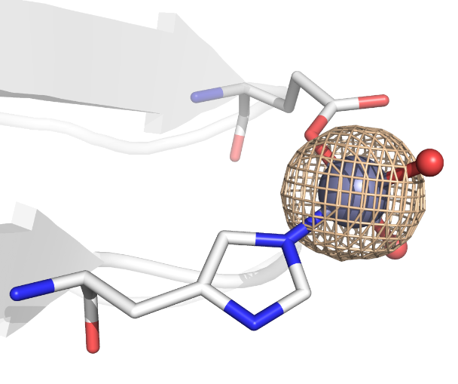

**Figure 1**. This is a figure caption (Heading 6 style, Times New Roman 9 pt).

References should be given in the text by square brackets [1]. Two or more references at a time may be put in one set of brackets [2-4] or [2, 3]. The references are to be numbered in the order in which they are cited in the text.

Use equation editors for equations, with layout as in this example, eq. (1):

*a²+b² = c²*

. (1)

The references should be in Heading 4 style (Times New Roman 9 pt) and listed immediately at the end of the text without a heading.

[1] Margilies, L., Kramer, M. J., McCallum, R. W., Kycia, S., Haeffner, D. R., Lang, J. C. & Goldman, A. I. (1999). *Rev. Sci. Instrum.* **70**, 3554.

[2] Chupas, P. J., Ciraolo, M. F., Hanson, J. C. & Grey, C. P. (2001). *J. Am. Chem. Soc.*, **123**, 1694.

[3] Bunge, H. J. (1982). *Texture Analysis in Materials Science*. London: Butterworth.

[4] Balzar, D. & Popa, N. C. (2004). *Diffraction Analysis of the Microstructure of Materials*, edited by E. J. Mittemeijer & P. Scardi, pp. 125-145. Berlin: Springer.

*Any acknowledgements authors wish to make should be included at the end of the abstract with no heading (use Acknowledgement style, Times New Roman 10 pt, italics).*